

**ProshotX Profile**

**Derek Griffin Shooting Specialist and Professional Profile**

*The creator of ProShotx has a lifetime experience of making shots. He took is success of making shots on the big stage to his passion of teaching youth. He discovered a common trend between the great shooters of the world. He then tested these new discoveries on thousands of basketball players. He now wants to share it with the world!*

**High School: Whitehall High School**

All-State: Averaged 24 points a game

**Junior College: Muskegon Community College**

Shooting Guard

All-Conference

All-State

All-Region

All-American

MVP of Michigan JUCO All Star Game

Played in JUCO All American All-Star Game

Average: 18 points/game

**Calvin College:**

Shooting Guard

All-Conference 1st Team

Player of the week 6 times

TIP-Off Tournament MVP

Hall of Fame Classic MVP

Average: 15 points/game

College Career 3 pointers made: 321

**Grand Rapids Flight (Professional ABA)**

Average: 18 points/game

**Oklahoma Outlaws (Professional ABA)**

**USA Basketball 3x3 National (2013, 2015)**

MVP of National Championship

Captain of Team

**FIBA World Tour:**

2012 North American Champions (New York)

2012 World Championships 5th Place (Miami)

2012 #1 Ranked team in the United States

2012 #1 Ranked Player in the United States

2012 #1 Ranked Player in the Western Hemisphere

2013 Puerto Rico 3rd place

2013 #1 Ranked Team in the United States

2013 # 1 Ranked Player in the United States

2013 Copa America 2nd Place (Brazil)

2014 North American Runner Up (Chicago)

2014 Copa America 2nd Place (Brazil)

2014 Olympic Friendly Game (Tokyo)

2014 #1 Ranked Team in United States

2015 North American Champions (Mexico)

2015 #1 Ranked Team in United States

2015 #1 Ranked Player in the United States

Derek Griffin also won the 3-point Championship at the FIBA World Championships in Abu

Dhabi

Speaker at the World Basketball Festival

**Denver Nuggets Director of Youth Development (2010-2015)**

Gary Harris Camp Director

George Karl Camp Director

Javale McGee Camp Director

Arron Afflalo Camp Director

**Hardwood Evolution (2016-Present)**

**USA Basketball Regional Coordinator (2016-Present)**

**Shooting Philosophy**

Golf, Baseball, Football and Hockey are the most studied sports in the world. The technique of throwing and swinging have been scientifically studied for decades. Shooting a basketball has now been scientifically studied and proven. NBA Shooting coaches have always lived and relied on the philosophy of “perfecting YOUR shot.” This has lead to countless players struggling for a lifetime of trying to make shots. Just “repping” until your arm falls off will not work! ProShotx has a proven system to become a consistent maker!

**Mission**

Our mission is to stop the epidemic of bad shooting strategy by using scientific data and physics to explain why the best shooters in the world make shots. Then we will teach you the secrets that we have unfolded!

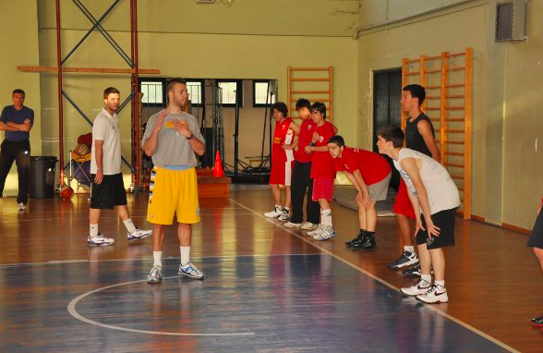

Teaching Shooting in Greece

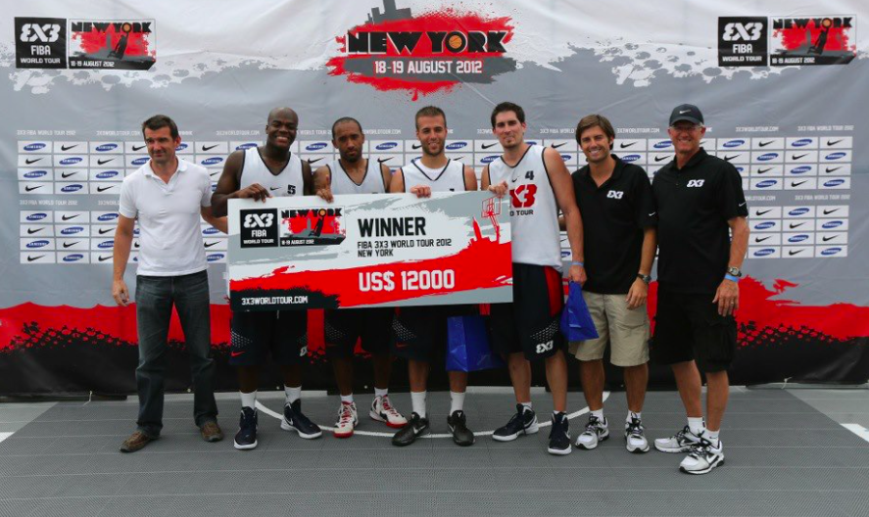

2012 World Tour North American Champs – New York

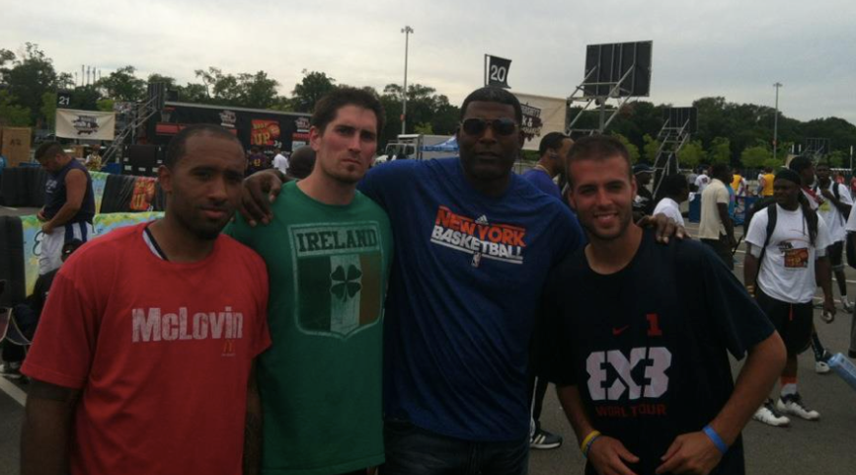

World Tour with former NBA great Larry Johnson

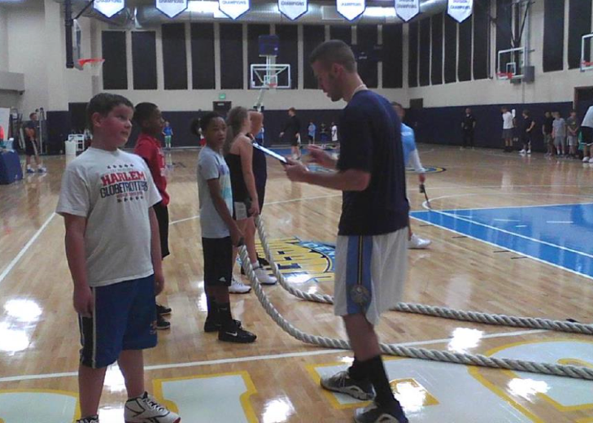

Directing George Karl Basketball Clinic

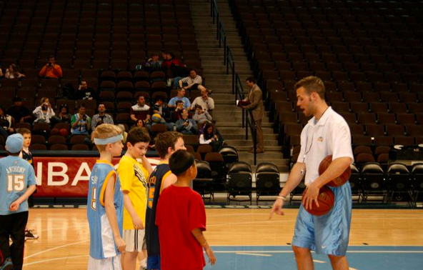

Clinic at the Pepsi Center

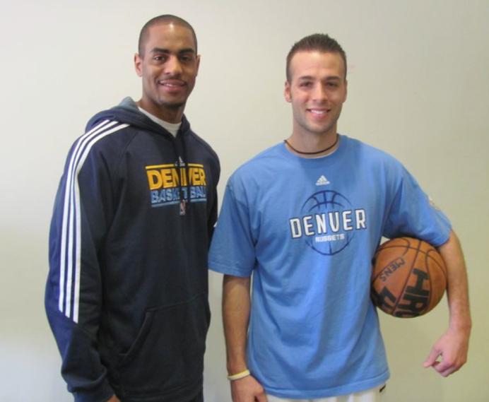

Arron Afflalo Camp

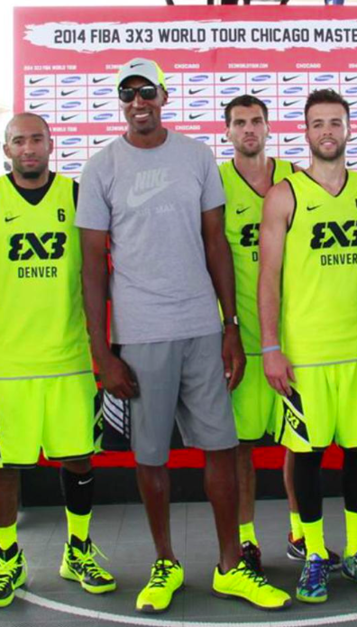

3x3 World Tour Champions with Scottie Pippen

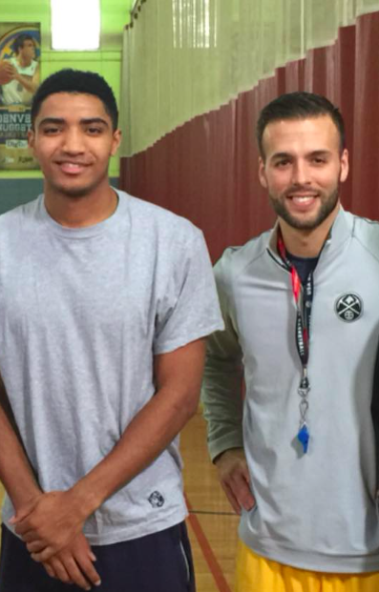

Directed Garry Harris Camp

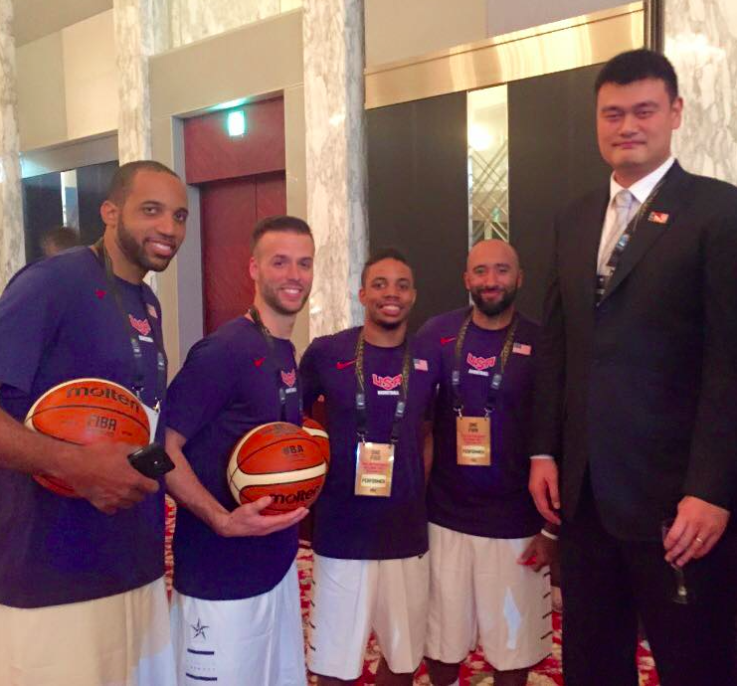

USA National Team in Japan with Yao Ming

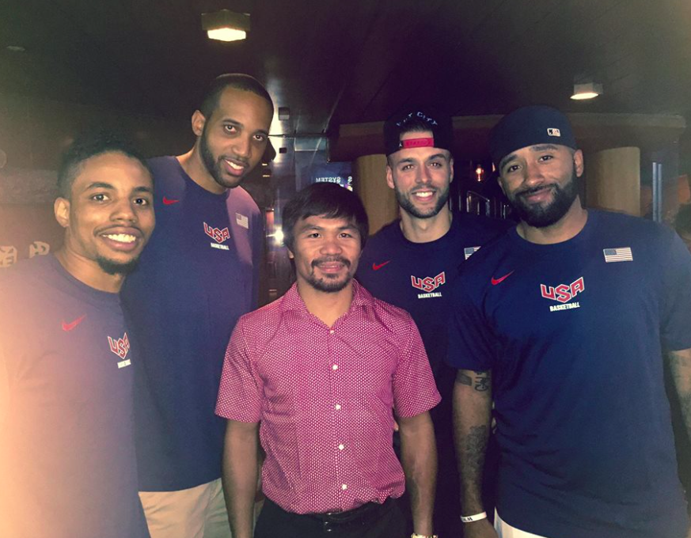

USA National Team with Manny Pacquiao

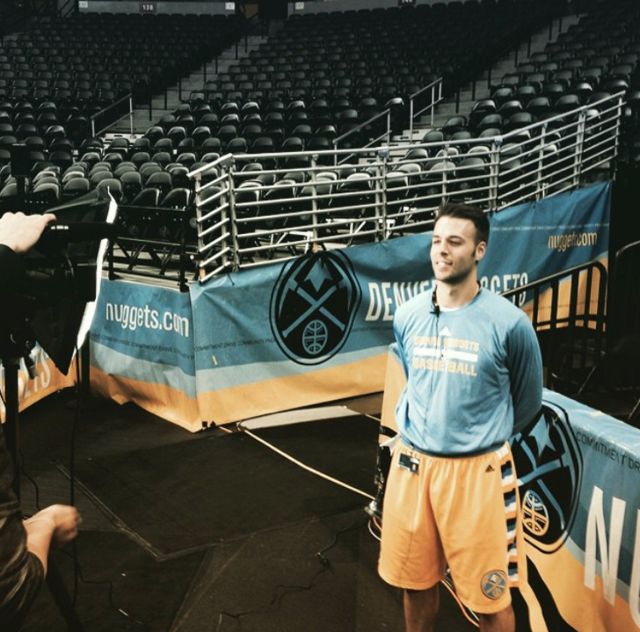

Director of Youth Development for Denver Nuggets

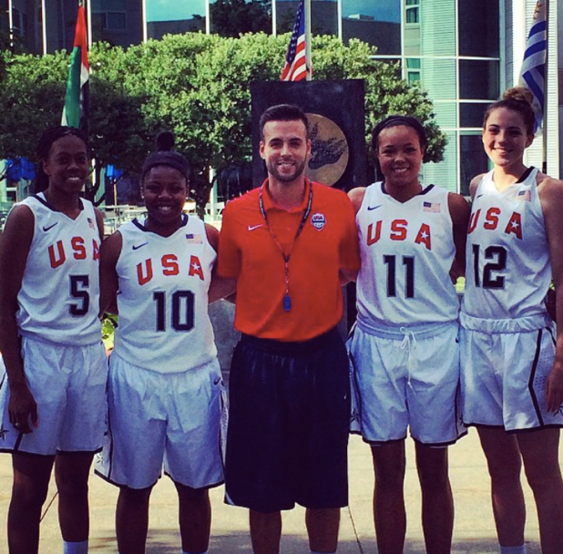

USA Basketball Regional Coordinator for 3x3

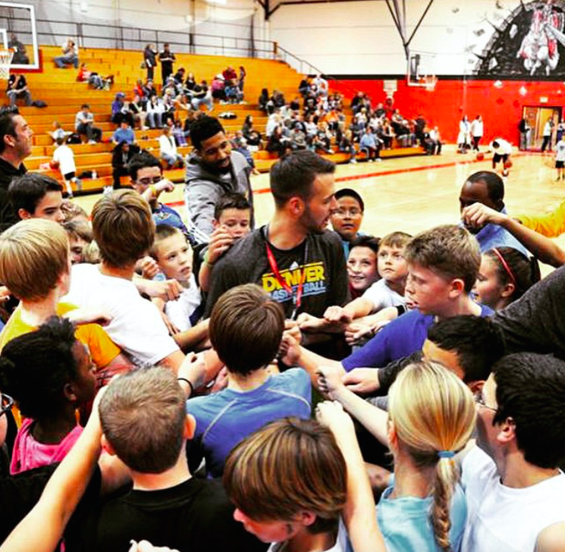

Denver Nuggets Youth Director with Wilson Chandler

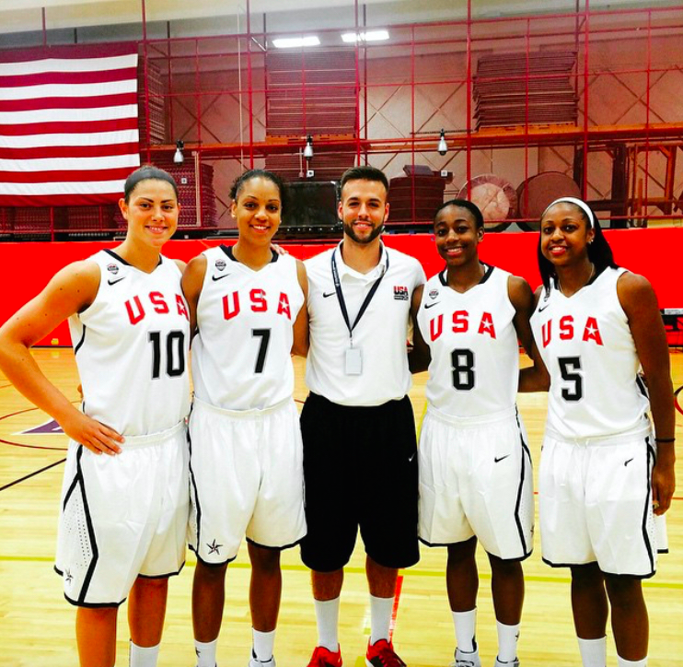

USA Basketball Regional Coordinator with 3x3 National Team

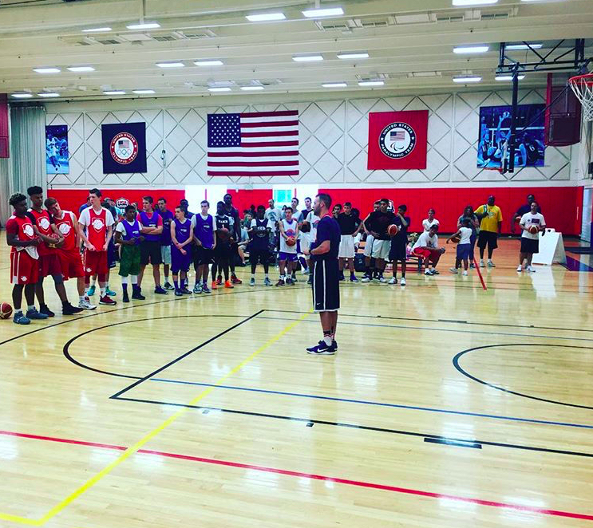

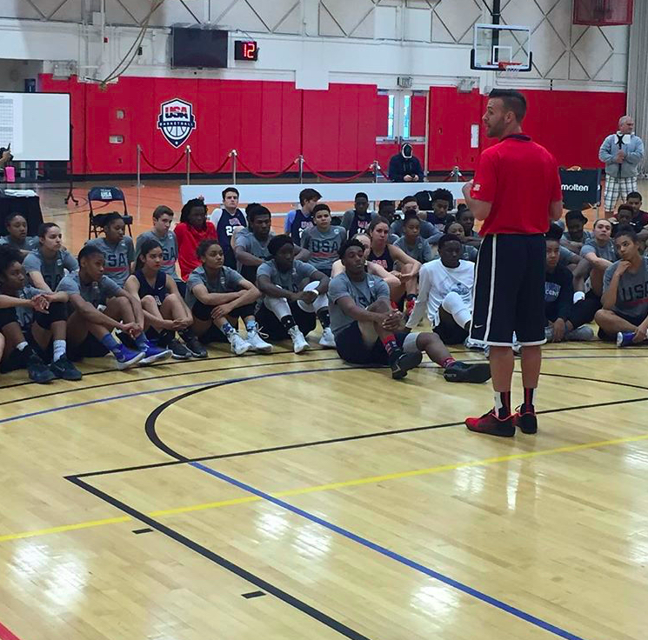

USA Basketball

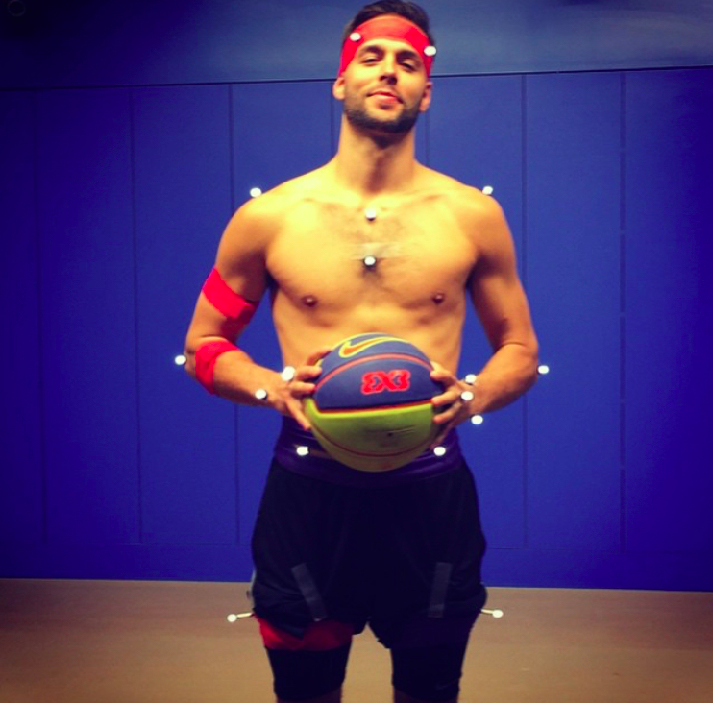

Children Hospital Motion Lab Analyzed my shot